**We have provided two alternatives in case one does not work:**

1. **If viewing code from Github**

Open in Github Desktop

Open in VS Code

Set powershell as default terminal:

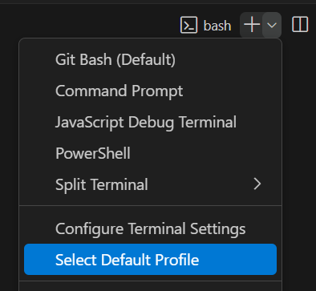

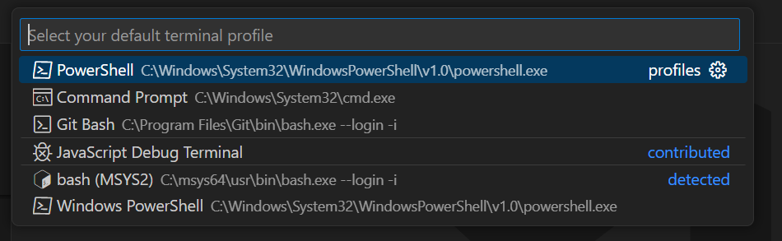

Open in HMS integrated terminal

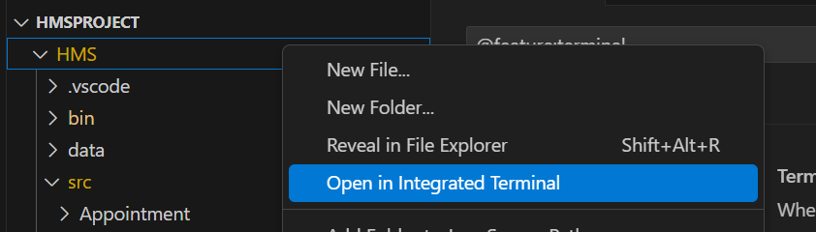

**Copy paste in terminal**

**For mac:**

javac -d bin -sourcepath src src/**/*.java

java -cp bin Application

**For windows:**

javac -d bin -sourcepath src (Get-ChildItem -Recurse -Filter *.java -Path src | ForEach-Object { $_.FullName })

java -cp bin Application

If importing of files was successful, the following should be visible

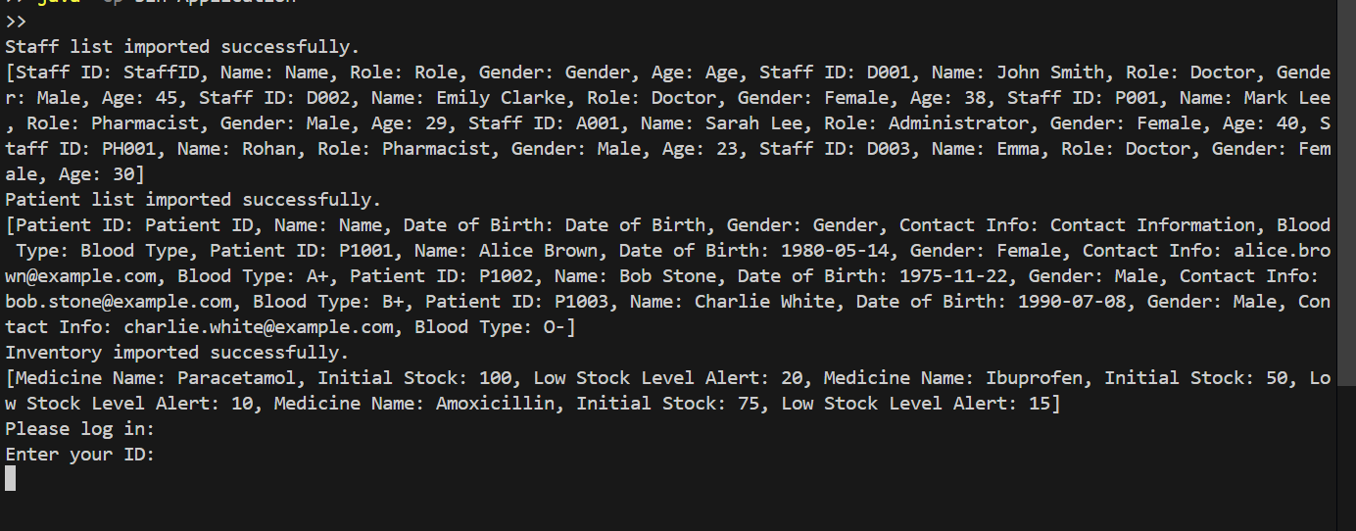

If not, please try out the second alternative

1. **If using zip file:**

Open folder in VS Code

Medicine_List.csv - Copy Path and paste into Inventory.java (please add double quotations)

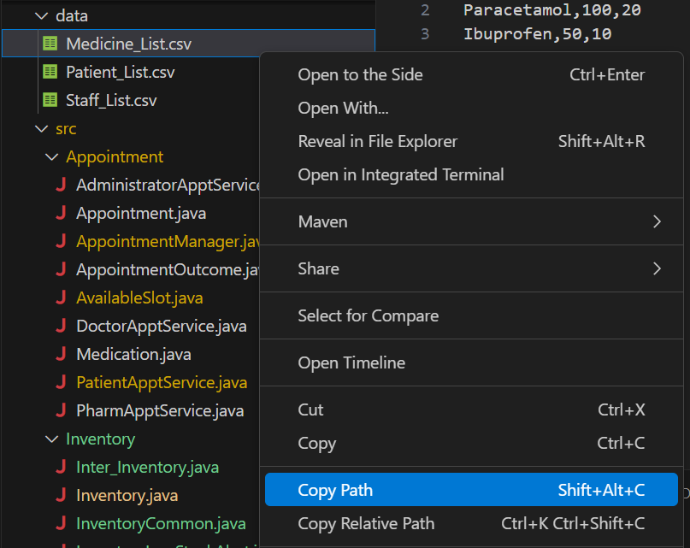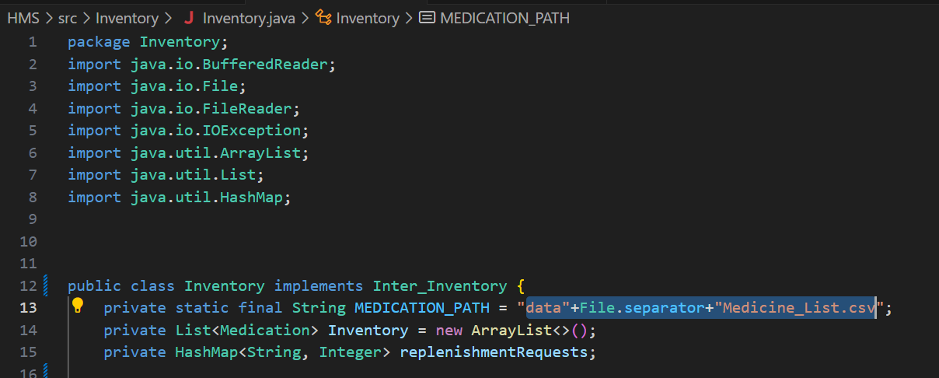

Patient_List.csv: Copy Path and Paste into patientIN (please add double quotations)

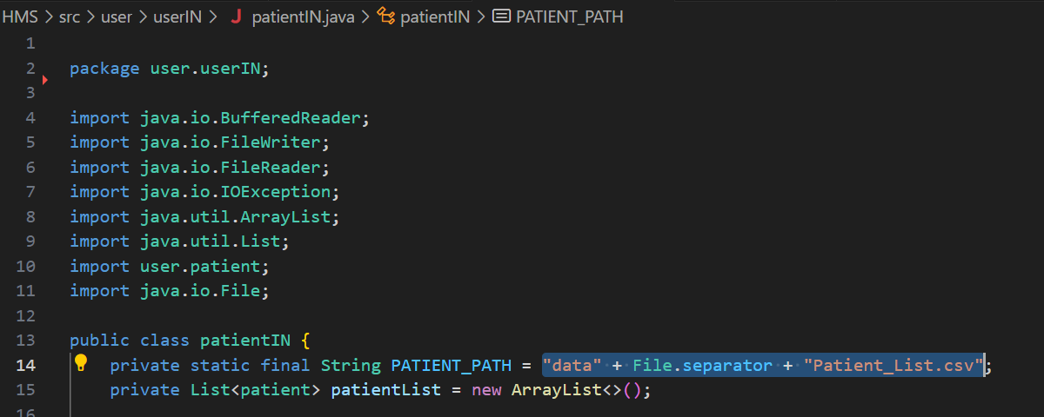

Staff_List.csv: Copy Path and paste into staffIN (please add double quotations)

